PID Controller — Op-Amp Circuit Simulation Report
Name: KURUVA PUNEETH KUMAR Date: ___27-08-2026___
Simulated in TinkerCAD Circuits

The oscilloscope captures below document the response of the op-amp PID controller stages to Sine, Square, and Triangle input waveforms, simulated in TinkerCAD Circuits.

TinkerCAD Project Link
[Link]

Triangle Wave — Input Response Tests
Figure 1. Stage: Input: Triangle Wave
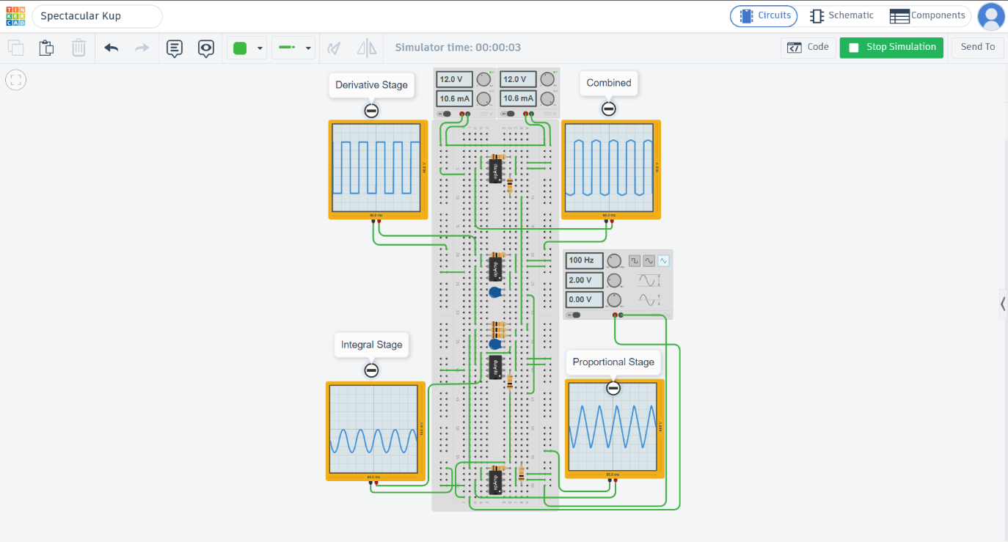
Function generator: 100 Hz, 2.00 V amplitude, 0.00 V offset

Triangle Wave — Input Response Tests
Figure 1. Stage: Input: Triangle Wave
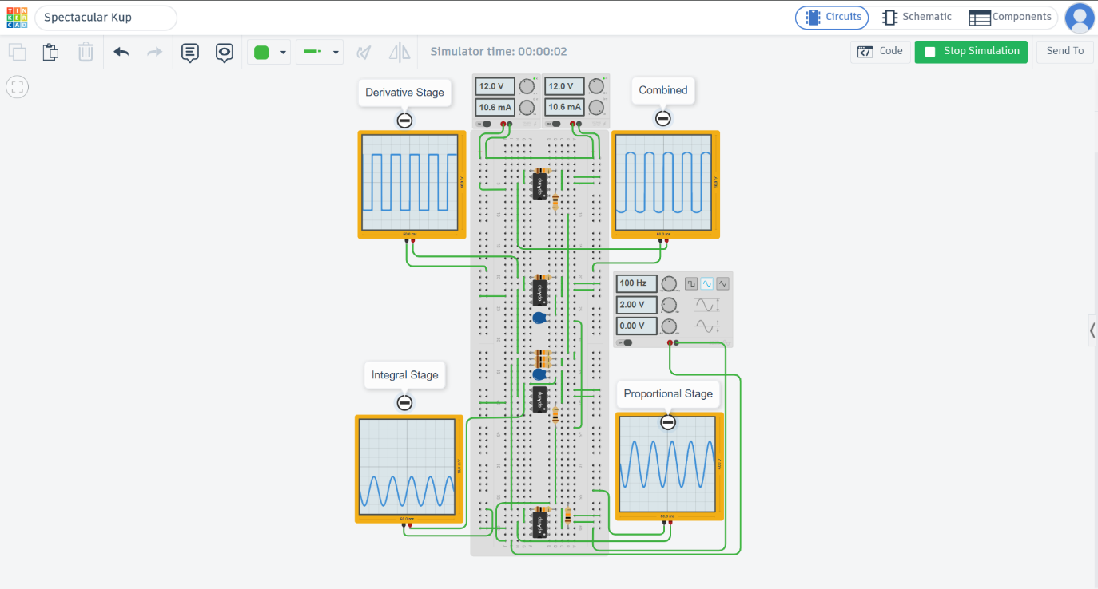
Function generator: 100.0 Hz, 2.00 V amplitude, 0.00 V offset

Square Wave — Input Response Tests
Figure 3. Stage: Input: Square Wave
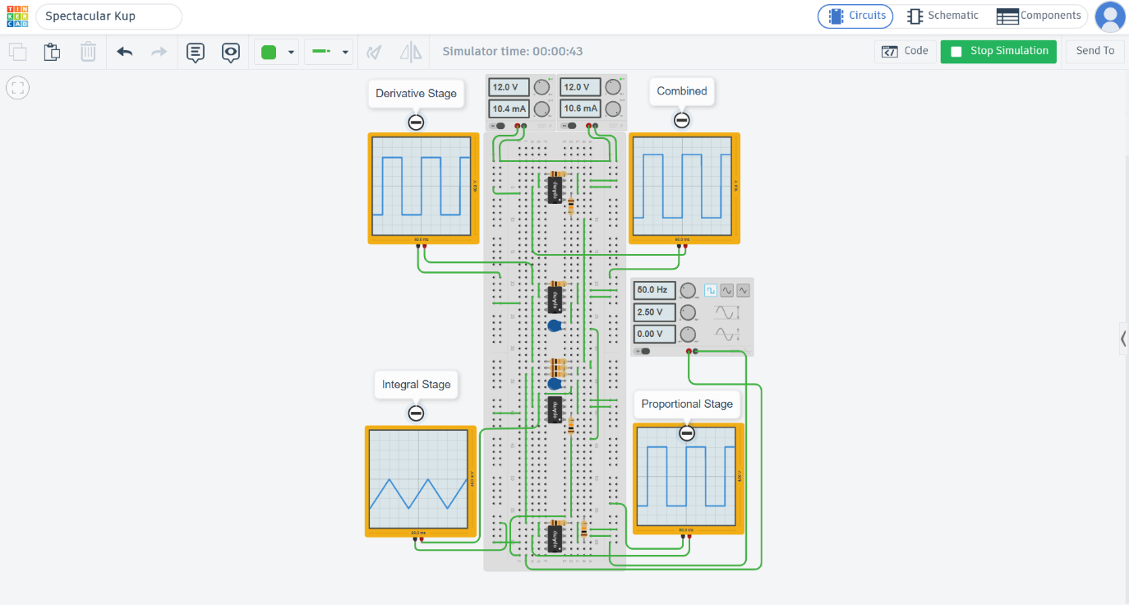
Function generator: 500 Hz, 2.50 V amplitude, 0.00 V offset

